Ventura Pilot Evaluations
User Manual

Ventura Air Services

May 2026

Table of Contents
1. Overview
2. Getting Started
3. Creating a New Evaluation
4. Evaluation Detail Screen
5. Grading Items
6. Flight Log
7. Completing an Evaluation
8. PDF Report
9. Export and Import
10. Settings
11. Tips and Best Practices

1. Overview
Ventura Pilot Evaluations is an iOS application developed for Ventura Air Services to evaluate pilots during their Initial Operating Experience (IOE), PIC Upgrades, and Random evaluations. The app replaces the paper-based VAS Pilot Evaluation Worksheet, allowing evaluators to grade pilots across 12 sections covering all phases of flight operations.
The application supports multi-day, multi-session evaluations, flight logging, PDF report generation, and cross-device evaluation transfer via export and import.
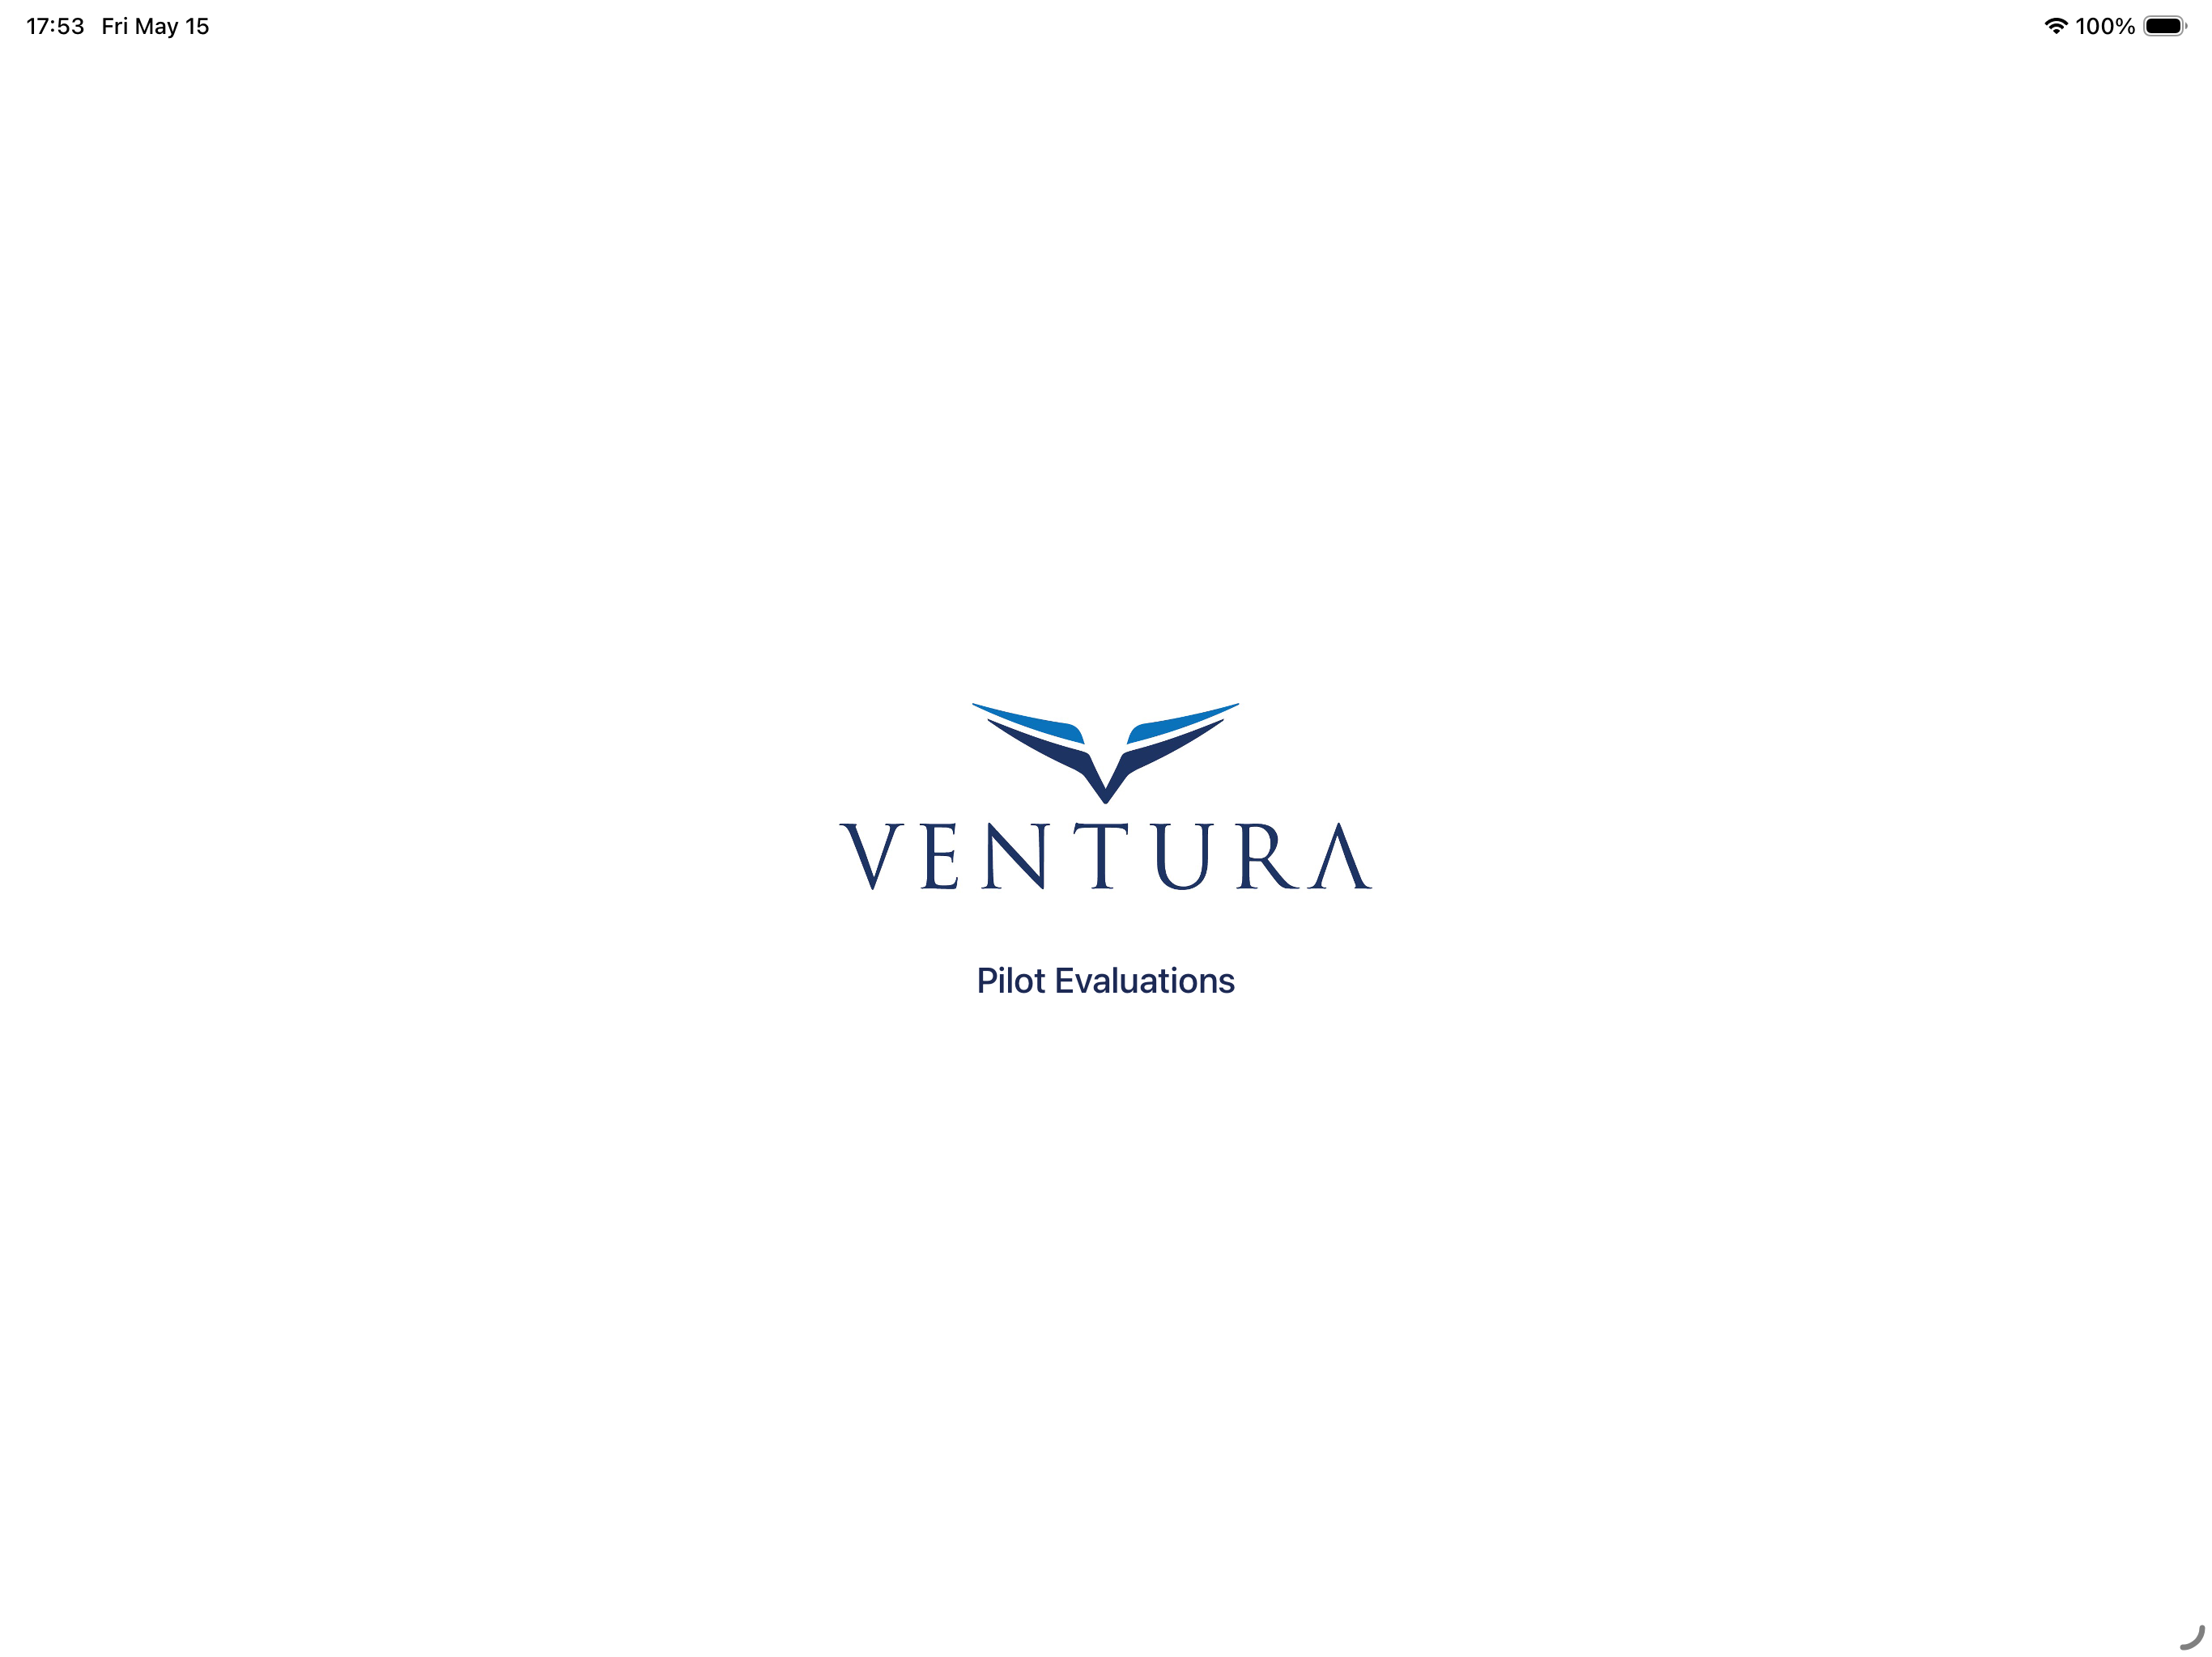

2. Getting Started
When the app launches, you will see the Ventura Air Services splash screen followed by the main Pilot Evaluations screen.

Main Screen
The main screen displays all evaluations organized into two sections:
- In Progress - Evaluations that are currently being worked on
- Completed - Evaluations that have been finalized

Each evaluation row shows:
- Pilot name and status badge (New, In Progress, Session #, or Complete)
- Evaluation type (IOE, PIC Upgrade, or Random)
- Position (PIC or SIC) and aircraft type
- Date created
- Progress bar (orange if unsatisfactory items exist, green otherwise)
[ Screenshot: Main Screen - Pilot Evaluations List ]

Navigation
- Gear icon (top left) - Opens Settings
- Plus icon (top right) - Opens a menu to create a new evaluation or import one
- Swipe left on any evaluation to delete it
[ Screenshot: Main Screen - Navigation Elements ]

3. Creating a New Evaluation
To create a new evaluation:
- Tap the + icon and select New Evaluation
- Fill in the form:
- Tap Create to save

The form includes the following fields:
Field | Description
Evaluation Type | Select IOE, PIC Upgrade, or Random (segmented control)
Evaluator | Enter the evaluator's name
Last Name / First Name / M.I. | Enter the pilot's name (last and first name required)
Position | Select PIC or SIC (segmented control)
Aircraft Type | Select Citation or Challenger (segmented control)
N Number(s) | Optional - Enter the aircraft N number(s)

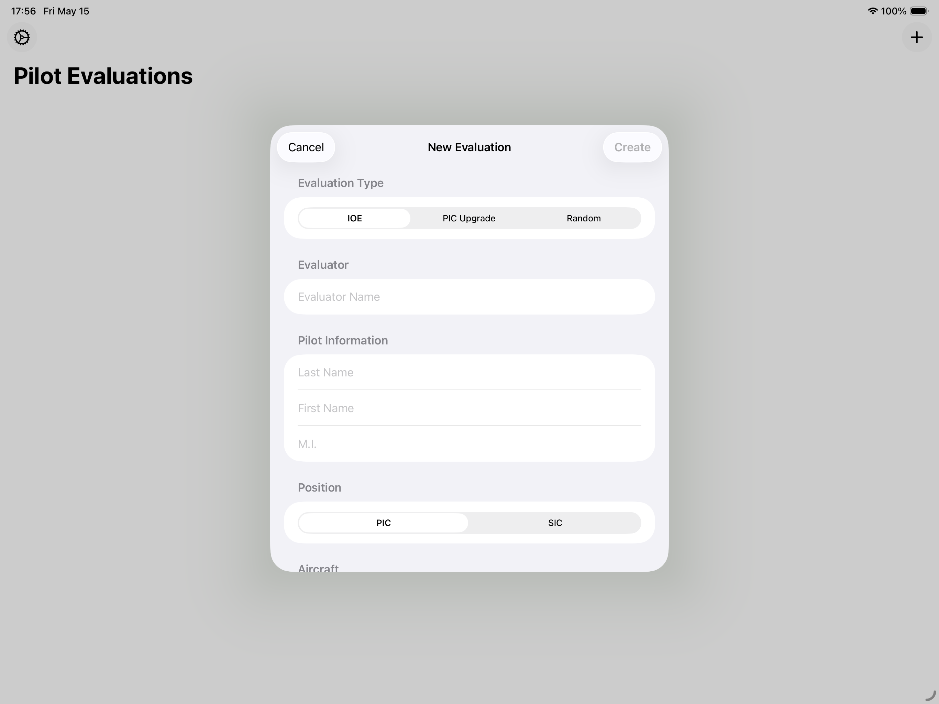

4. Evaluation Detail Screen
Tap on any evaluation to open its detail screen. This screen is the hub for all evaluation activities.
[ Screenshot: Evaluation Detail Screen - In Progress ]

Action Buttons
For in-progress evaluations, the following action buttons are available:
- Start Grading / Continue Grading - Opens the grading form to evaluate all 63 items across 12 sections.
- Flight Log - Opens the flight log to record flights associated with this evaluation.
- Review Unsatisfactory Items - Appears after all items are graded if any items received a grade of 1 or 2. Starts a new session showing only unsatisfactory items for re-evaluation.
- Complete Evaluation - Appears after all items are graded. Prompts for the certifying pilot's name to finalize.

Pilot Information
Displays all pilot and evaluation details: evaluation type, evaluator name, pilot name, position, aircraft type, N numbers, date created, and current session number.

Progress
Shows a progress bar and grade breakdown:
- Proficient (green) - Items graded 3
- Unsatisfactory (orange) - Items graded 1 or 2
- N/A (gray) - Items marked Not Applicable
- Not Evaluated (gray) - Items marked Not Evaluated
[ Screenshot: Progress Section with Grade Breakdown ]

Comments
Displays all items that have comments, showing the element code, grade, item name, and comment text.

5. Grading Items
The grading screen displays all 12 evaluation sections with their items. Sections are expanded by default.
[ Screenshot: Grading Screen - Sections View ]

Grading Scale
Grade | Meaning | Color
1 | Not Proficient | Red
2 | Gaining Proficiency | Orange
3 | Proficient | Green
NA | Not Applicable | Gray
NE | Not Evaluated | Gray

How to Grade
For each item, tap a grade button (1, 2, 3, NA, or NE) to assign a grade.
- Tap the same grade again to remove it
- Items graded 1 or 2 (unsatisfactory) automatically show a comment field
- Comments are required for unsatisfactory items
- Tap Save to save and return, or simply navigate back (changes auto-save)
[ Screenshot: Grading an Item with Comment Field ]

Section Controls
- Tap any section header to collapse or expand it
- Use the collapse/expand button (top left) to toggle all sections at once
- Each section header shows grading progress (e.g., "5/9") and unsatisfactory count

Evaluation Sections (63 items)
Section | Items
1. Preflight (9 items) | Crew Briefing, Flight Planning, Weather/NOTAMs/TFR, Exterior Inspection, Cockpit Preflight, W&B/Performance, Fuel Loading & Procedures, Aircraft Appearance, Customer Care
2. Before Takeoff (5 items) | Takeoff Briefing, NAV/FMS Setup, Flight Director Setup, Engine Start, Taxi
3. Takeoff / Climb (6 items) | Runway Alignment, Thrust Setting, Speed Control, Crosswind Control, Rotation, Use of Automation
4. Cruise (4 items) | Use of Automation, Flight Management, Fuel Awareness, Customer Care
5. Descent (6 items) | Descent Planning, Descent Management, Use of Automation, Approach Briefing, Approach Setup, Customer Care
6. Approach / Landing (10 items) | Approach Profile, Stabilized Approach, Use of Automation, Speed Control, Flap/Gear Management, Crosswind Control, Touchdown Point, Brakes/Reverse Thrust, Directional Control, Taxi/Parking
7. Shutdown / Deplane (3 items) | Engine Shutdown, Passenger Deplane, Customer Care
8. Post Flight (3 items) | Company Communication, Aircraft Appearance, Exterior Inspection
9. Securing (4 items) | Aircraft Chocked, Gust/Control Lock, Battery Disconnected, Damage Avoidance
10. General (5 items) | Judgement, CRM, Uniform/Appearance, Timeliness, Required Documents
11. Procedures (5 items) | High Altitude Airports, Mountainous Airports, Cold Weather Ops, International Procedures, Thunderstorms/Wx Radar
12. Company (5 items) | Crew Rules & Standards, Ops Specs, SOP's, Safety Reporting, Communications

Multi-Session Evaluations
Evaluations can span multiple days and sessions:
- Grade items over the course of your evaluation period
- After all items are graded, if any are unsatisfactory, the "Review Unsatisfactory Items" button appears
- Tapping it starts a new session and presents only the unsatisfactory items
- This process can repeat across multiple sessions until all items are satisfactory
- The session number is tracked and displayed in the evaluation detail
[ Screenshot: Review Unsatisfactory Items Button ]

6. Flight Log
The flight log allows you to record flights associated with the evaluation.

Adding Flights
- From the evaluation detail screen, tap Flight Log
- Tap Add Flight to add a new entry
- For each flight, enter:

Each flight entry contains:
Field | Description
Date | Select the flight date using the date picker
Departure | Enter the departure airport (ICAO code)
Arrival | Enter the arrival airport (ICAO code)
Block Time | Enter the block time in decimal hours (e.g., 2.5)

- The Total Block Time is displayed at the bottom, summing all entries
- Flights are automatically sorted from newest to oldest date
- Swipe left on any flight entry to delete it
- Tap Save to save and return
[ Screenshot: Flight Log Screen with Entries ]

7. Completing an Evaluation
Once all items have been graded:
- Review any unsatisfactory items if needed (see Multi-Session Evaluations)
- Tap Complete Evaluation
- Enter the certifying pilot's name when prompted
- Tap Complete to finalize

Once completed, the evaluation moves to the Completed section on the main screen and can no longer be edited. You can still generate PDF reports and export the evaluation.
[ Screenshot: Complete Evaluation - Certifying Pilot Prompt ]

[ Screenshot: Completed Evaluation Detail ]

8. PDF Report
The PDF report is a 3-page document that mirrors the original VAS Pilot Evaluation Worksheet.

Page 1 - Evaluation Grid
- Ventura Air Services logo and company name
- Pilot information (name, position, evaluation type, aircraft, N numbers, evaluator)
- Grading legend
- 3-column grid showing all 12 sections with color-coded item grades
[ Screenshot: PDF Report - Page 1 (Evaluation Grid) ]

Page 2 - Comments
- Element codes, grades, and comments for all items with comments
- Signature area for pilot and certifying pilot
[ Screenshot: PDF Report - Page 2 (Comments) ]

Page 3 - Flight Log
- Pilot name, aircraft type, and total block time
- Table of all logged flights (date, departure, arrival, block time)
[ Screenshot: PDF Report - Page 3 (Flight Log) ]

Generating and Sharing
- Tap Generate PDF Report from the evaluation detail screen
- Preview the PDF in the app
- Tap the share icon (top right) to share via AirDrop, email, print, save to Files, etc.
[ Screenshot: PDF Preview with Share Button ]

9. Export and Import
Evaluations can be transferred between devices using JSON export and import. This allows an evaluation started on one device to be continued on another.

Exporting an Evaluation
- Open the evaluation detail screen
- Tap Export Evaluation
- Choose a sharing method (AirDrop, Messages, email, save to Files, etc.)
[ Screenshot: Export Evaluation - Share Sheet ]

Importing an Evaluation
- From the main screen, tap the + icon and select Import Evaluation
- Browse for and select a previously exported JSON file
- You will be asked "Add Evaluator?"

When prompted to add an evaluator:
- Yes - If the evaluation already has an evaluator, the new name will be appended (e.g., "John Smith, Jane Doe")
- No - The evaluation is imported as-is

A confirmation message appears when the import is successful. If the imported evaluation has the same ID as an existing evaluation, a new ID is automatically assigned to avoid conflicts.
[ Screenshot: Import Evaluation - Add Evaluator Prompt ]

10. Settings
Tap the gear icon on the main screen to access Settings.
The settings page displays:
- App Version - The current version of the application
- Build Number - The current build number
[ Screenshot: Settings Screen ]

11. Tips and Best Practices
Tip: You can close the app and return at any time. Your progress is automatically saved.

Tip: Export an evaluation from one device and import it on another to continue grading with a different evaluator.

Tip: Use the collapse/expand all button in the grading screen to quickly navigate to the section you need.

Tip: Tap a grade to assign it, tap the same grade again to remove it. The full grade history is tracked across sessions.

Tip: Always add detailed comments for items graded 1 or 2. These comments appear on the PDF report and are important for documenting the evaluation.

Tip: Flight logs are sorted from newest to oldest. The total block time is displayed both in the app and on page 3 of the PDF report.

